**TEAM ID : PNT2022TMID26050**

**PROJECT NAME: PERSONAL ASSISTANCE FOR SENIORS WHO ARE SELF**

**RELIANT**

IBM WATSON IOT & DEVICE CREATION

STEP 1: CLICK ON CATALOG

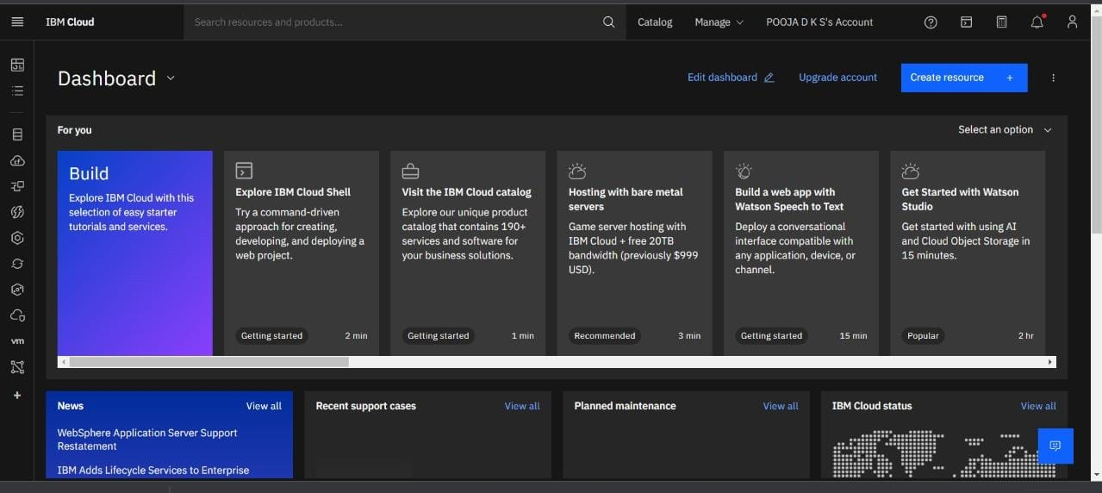

STEP 2:

GO TO IOT PLATFORM

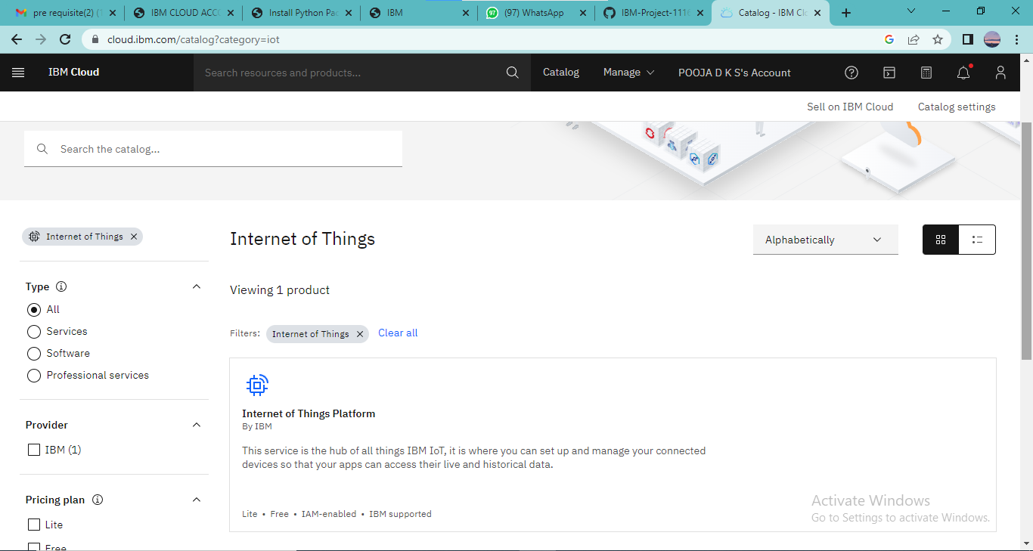

STEP 3:

SIGN IN USING IBM ID AND PASSWORD

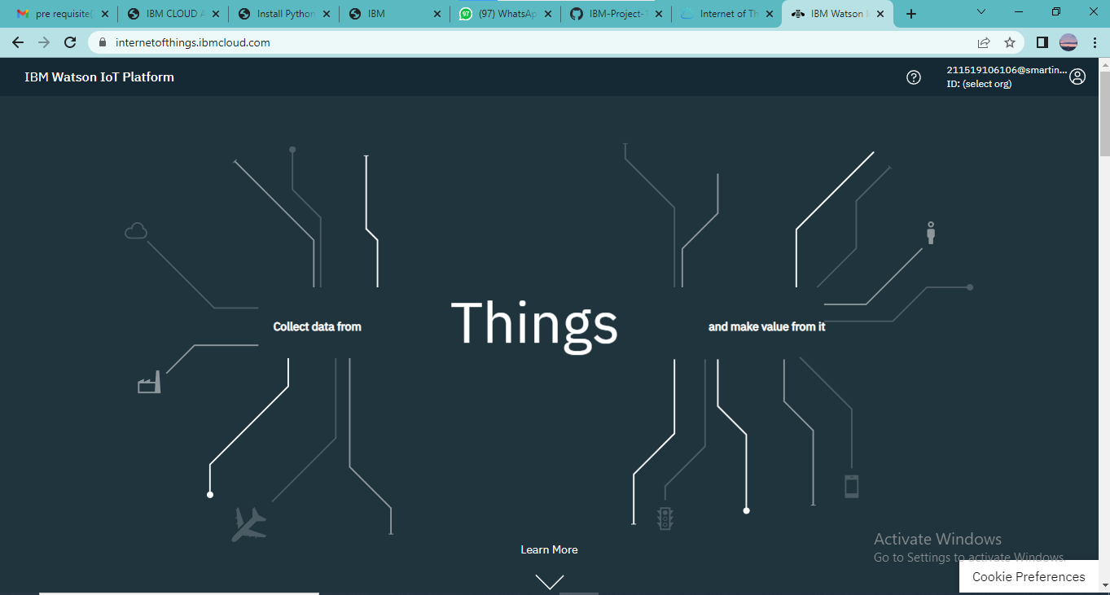

STEP 4:

CREATE THE DEVICE

